OOPs (Object-Oriented Programming System)

**Object** means a real-world entity such as a pen, chair, table, computer, watch, etc. **Object-Oriented Programming** is a methodology or paradigm to design a program using classes and objects. It simplifies software development and maintenance by providing some concepts:

Object

Class

Inheritance

Polymorphism

Encapsulation

Abstraction

# **Inheritance in Java**

**Inheritance in Java** is a mechanism in which one object acquires all the properties and behaviors of a parent object.

### **Terms used in Inheritance**

* **Class:** A class is a group of objects which have common properties. It is a template or blueprint from which objects are created.
* **Sub Class/Child Class:** Subclass is a class which inherits the other class. It is also called a derived class, extended class, or child class.
* **Super Class/Parent Class:** Superclass is the class from where a subclass inherits the features. It is also called a base class or a parent class.
* **Reusability:** As the name specifies, reusability is a mechanism which facilitates you to reuse the fields and methods of the existing class when you create a new class. You can use the same fields and methods already defined in the previous class.

### **The syntax of Java Inheritance**

1. **class** Subclass-name **extends** Superclass-name
2. {
3. //methods and fields
4. }

EXAMPPLE PROGRAM:

1. **class** Employee{
2. **float** salary=40000;
3. }
4. **class** Programmer **extends** Employee{
5. **int** bonus=10000;
6. **public** **static** **void** main(String args[]){
7. Programmer p=**new** Programmer();
8. System.out.println("Programmer salary is:"+p.salary);
9. System.out.println("Bonus of Programmer is:"+p.bonus);
10. }
11. }

OUTPUT:

Programmer salary is:40000.0

Bonus of programmer is:10000

Types of inheritance in java….

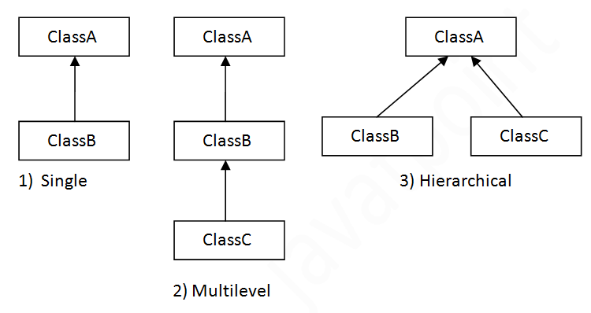

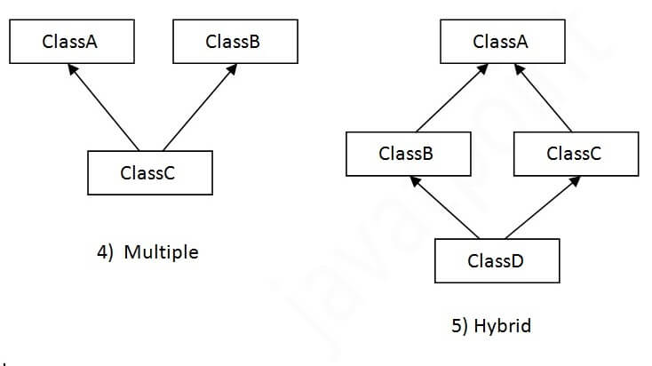

Single Inheritance Example

When a class inherits another class, it is known as a *single inheritance*. In the example given below, Dog class inherits the Animal class, so there is the single inheritance.

*File: TestInheritance.java*

1. **class** Animal{
2. **void** eat(){System.out.println("eating...");}
3. }
4. **class** Dog **extends** Animal{
5. **void** bark(){System.out.println("barking...");}
6. }
7. **class** TestInheritance{
8. **public** **static** **void** main(String args[]){
9. Dog d=**new** Dog();
10. d.bark();
11. d.eat();
12. }}

Output:

barking...

eating...

## Multilevel Inheritance Example

When there is a chain of inheritance, it is known as multilevel inheritance. As you can see in the example given below, BabyDog class inherits the Dog class which again inherits the Animal class, so there is a multilevel inheritance.

*File: TestInheritance2.java*

1. **class** Animal{
2. **void** eat(){System.out.println("eating...");}
3. }
4. **class** Dog **extends** Animal{
5. **void** bark(){System.out.println("barking...");}
6. }
7. **class** BabyDog **extends** Dog{
8. **void** weep(){System.out.println("weeping...");}
9. }
10. **class** TestInheritance2{
11. **public** **static** **void** main(String args[]){
12. BabyDog d=**new** BabyDog();
13. d.weep();
14. d.bark();
15. d.eat();
16. }}

Output:

weeping...

barking...

eating...

## Hierarchical Inheritance Example

When two or more classes inherits a single class, it is known as hierarchical inheritance. In the example given below, Dog and Cat classes inherits the Animal class, so there is hierarchical inheritance.

*File: TestInheritance3.java*

1. **class** Animal{
2. **void** eat(){System.out.println("eating...");}
3. }
4. **class** Dog **extends** Animal{
5. **void** bark(){System.out.println("barking...");}
6. }
7. **class** Cat **extends** Animal{
8. **void** meow(){System.out.println("meowing...");}
9. }
10. **class** TestInheritance3{
11. **public** **static** **void** main(String args[]){
12. Cat c=**new** Cat();
13. c.meow();
14. c.eat();
15. //c.bark();//C.T.Error
16. }}

Output:

meowing...

eating...

## Q) Why multiple inheritance is not supported in java?

To reduce the complexity and simplify the language, multiple inheritance is not supported in java.

Consider a scenario where A, B, and C are three classes. The C class inherits A and B classes. If A and B classes have the same method and you call it from child class object, there will be ambiguity to call the method of A or B class.

Since compile-time errors are better than runtime errors, Java renders compile-time error if you inherit 2 classes. So whether you have same method or different, there will be compile time error.

1. **class** A{
2. **void** msg(){System.out.println("Hello");}
3. }
4. **class** B{
5. **void** msg(){System.out.println("Welcome");}
6. }
7. **class** C **extends** A,B{//suppose if it were
9. **public** **static** **void** main(String args[]){
10. C obj=**new** C();
11. obj.msg();//Now which msg() method would be invoked?
12. }
13. }

OUTPUT:

Compile Time Error